STEP 1: Login to Athena with your UGA MyID and password.

STEP 2: Locate the Clear Advisement Holds card.
- You may need to click
STEP 3: Search by Student ID (81X) or name.
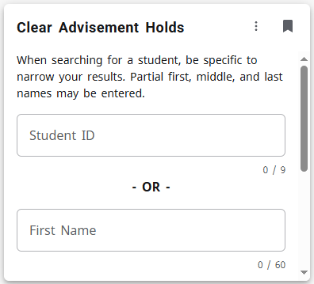
- Partial first, middle, and last names may be entered, but providing full names will narrow results.

STEP 4: Select a student by clicking on their name displayed below the search bar.
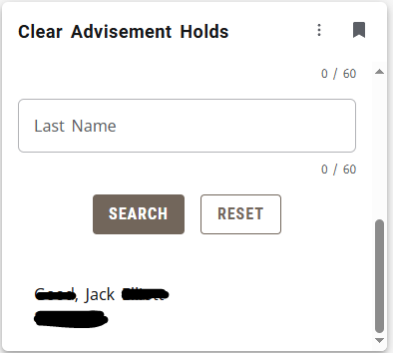

STEP 5: On the Clear Advisor Holds page, select the term you would like to clear. To select all terms, click the box next to “Term.”
- The name and 81X of the student will appear in the top left corner.
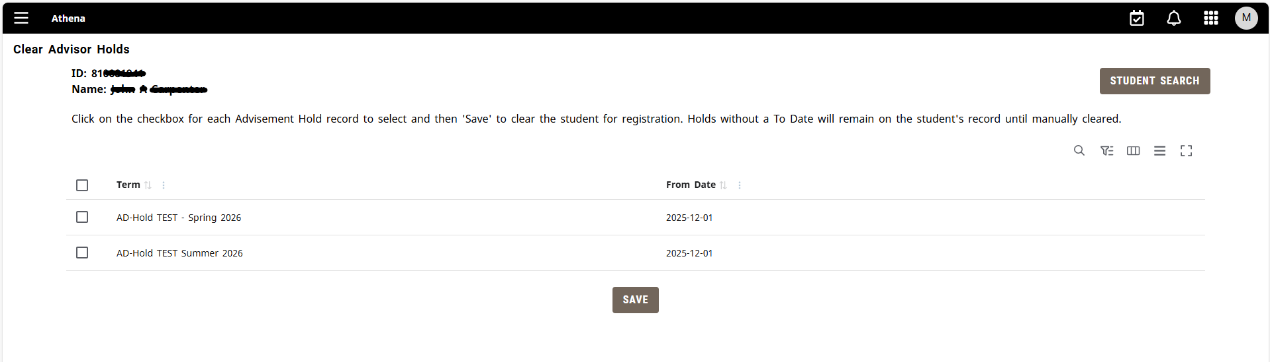
STEP 6: Once the applicable terms have been selected, click Save.
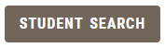
STEP 7: Click the Student Search button in the top right corner of the screen to search for another student.

